VISVESVARAYA TECHNOLOGICAL UNIVERSITY

BELAGAVI


A Project Report on
LUNG CANCER DETECTION SYSTEM USING CNN
Submitted in partial fulfillment of the requirement for the award of the degree of

MASTER OF COMPUTER APPLICATIONS
Under

VISVESVARAYA TECHNOLOGICAL UNIVERSITY
By
PAWAN KUMAR K.P
4SO23MC068


VISVESVARAYA TECHNOLOGICAL UNIVERSITY

BELAGAVI



A Project Report On
LUNG CANCER DETECTION SYSTEM USING CNN
Submitted in partial fulfillment of the requirement for the award of the degree of
MASTER OF COMPUTER APPLICATIONS
Under
VISVESVARAYA TECHNOLOGICAL UNIVERSITY
By
PAWAN KUMAR K.P
4SO23MC068
Under the Guidance of

Ms Sumangala N
Assistant Professor
Department of Computer Applications
St Joseph Engineering College
Mangaluru-575 028.



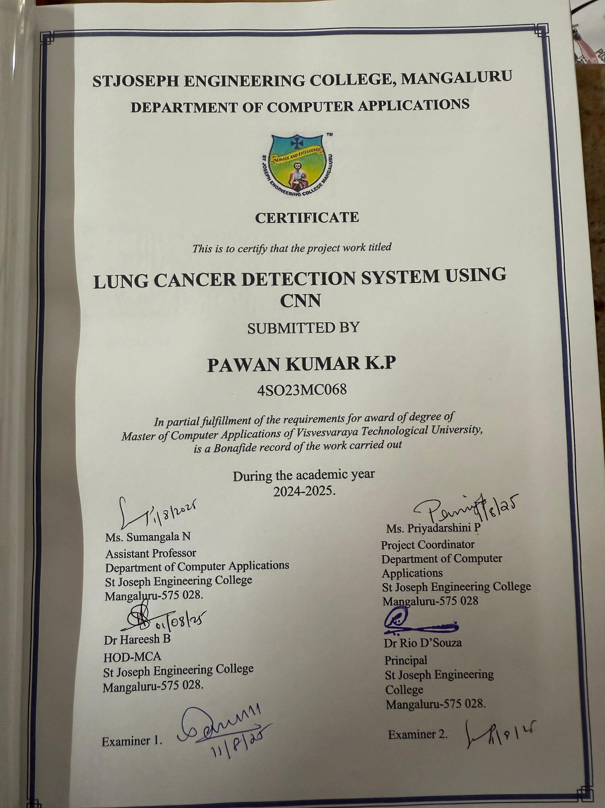


ACKNOWLEDGEMENT

It is my profound gratitude to thank one and all who have helped in bringing this project entitled “Lung Cancer Detection System Using CNN” up to the mark. Whatever I was able to put forward in terms of my work, is only due to few people from whom I learnt a lot.
Firstly, my sincere thanks to Rev. Fr Wilfred Prakash D’Souza, Director, SJEC, Fr Kenneth Rayner Crasta, Assistant Director, SJEC and Dr Rio D’Souza, Principal, SJEC, for their never-ending support and valuable suggestions. I wish to express my deep sense of gratitude to Mr. Hareesh B, HOD-MCA, for providing me the opportunity to take up this project. I would like to thank Ms. Sumangala N, Internal Guide & Assistant Professor-MCA, for her support and encouragement. I would also like to take this opportunity to convey my deep-felt gratitude to Ms. Priyadarshini P, Project Coordinator & Assistant Professor-MCA, who was there for us when required and I must say she has been the backbone of this Dissertation Report. I would also like to express my gratitude towards all the teaching and non-teaching staff of the Department of Computer Applications and to the other staff members of the college.
I extend my deepest gratitude to my beloved parents, whose unwavering love, sacrifices and constant encouragement have been the foundation of my journey. Their support—both emotional and moral—has been my greatest strength throughout the course of this project and my academic life.
I also wish to express my heartfelt thanks to my dear friends for their valuable suggestions, timely help and encouragement during various stages of the project.
Above all, I bow in reverence to God Almighty, whose infinite grace, guidance and blessings illuminated my path and gave me the strength and clarity to complete this project successfully. Without His divine presence and mercy, this work would not have been possible.
There are many others who have directly or indirectly helped me in my project work. The absence of their name does not show the absence of my gratitude for their support.

Pawan Kumar
31 July 2025

ABSTARCT

The rapid advancement of Artificial Intelligence in medical diagnostics has significantly improved the early detection of life-threatening diseases. This project presents a web-based lung cancer detection system designed using a Convolutional Neural Network (CNN) integrated with the Flask web framework. The core objective is to assist healthcare professionals by automating the classification of lung CT scan images into three categories: benign, malignant, and normal.

The proposed system employs a hybrid 2×2 CNN model that extracts spatial features through convolutional and pooling layers, followed by a dense classifier to determine the final prediction. The model is trained on a labelled CT scan dataset with appropriate preprocessing steps such as resizing, normalization, and augmentation. The classification output is further visualized using a graphical bar chart to enhance interpretability for end users.

The application includes three main user roles: Admin, Doctor, and Patient. Admins manage users and system data, doctors can view and assess medical predictions, and patients can upload their CT scan images to receive immediate feedback. The entire system runs on a Flask backend with MySQL database integration, offering a user-friendly interface for image uploads, prediction results, and report generation.

This system reduces diagnostic delay by providing automated predictions and promotes accessibility by offering remote usage. Future enhancements may include real-time image capture integration, multilingual support, and expansion of the model to detect additional respiratory diseases. By combining deep learning with web technology, this project aims to provide a scalable, efficient, and accurate decision-support tool for early lung cancer screening.

TABLE OF CONTENTS
- Introduction 01
- Literature Survey 02
- Software Requirements Specification 04
- System Design 13
- Detailed Design 19
- Implementation 31
- Software Testing 35
- Conclusion 41
- Future Enhancements 42
Appendix A: References 43
Appendix B: Screenshots 44

INTRODUCTION

  - Project Description 01

LITERATURE SURVEY
  - Existing and Proposed System 02
2.1.1 Existing System……………………………………………………………………….02
2.1.2 Proposed System……………………………………………………………………...02
  - Feasibility Study 02
  - Tools and Technologies Used 03

SOFTWARE REQUIREMENTS SPECIFICATION
  - Introduction 04
    - Purpose 04
    - Document Conventions/Definitions and Abbreviations 04
    - Intended Audience and Reading Suggestions 05
    - Project Scope 05
    - Benefits 06
    - References 06
  - Overall Description 07
    - Identification of Pre-existing work. 07
    - Product Perspective 07
    - Product Features 07
    - End User Characteristics 08
    - Operating Environment 08
    - Design and Implementation Constraints 08
    - Assumptions and Dependencies 08
  - Product Functionality 09
    - User Module ……………………………………………………………………….....09
    - Admin Module ……………………………………………………………………….09
    - Doctor Module ……………………………………………………………………….09
  - External Interface Requirements 09
    - User Interfaces 09
    - Hardware Interfaces 10
    - Software Interfaces 10
    - Communication Interfaces 10
  - Non Functional Requirements 10
    - Performance Requirements 10
    - Safety Requirements 11
    - Software Quality Attributes 11
      - Reliability…………………………………………………………………………….11
      - Maintainability ………………………………………………………………………11
      - Portability...…………………………………………………………………………..11
      - Usability……………………………………………………………………………...11
      - Flexibility…………………………………………………………………………….11
  - Specific Requirements 12
    - Operating Environment 12
      - Hardware 12
      - Software 12
  - Delivery Plan 12

SYSTEM DESIGN
  - System Design 13
    - Introduction 13
    - Scope of The Project 13
    - Intended Audience 14
    - Context Flow Diagram ……………………………………………………………….15
    - Admin DFD …………………………………………………………………………..16
    - Doctor DFD …………………………………………………………………………..17
    - Patient DFD …………………………………………………………………………..18

DETAILED DESIGN
  - Use Case Diagram 19
  - Sequence Diagrams 20
5.2.1Admin Sequence Diagram …………………………………………………………….20
5.2.2 Doctor Sequence Diagram ……………………………………………………………21
5.2.3 Patient Sequence Diagram ……………………………………………………………22
  - Activity Diagram 23
5.3.1 Admin Activity Diagram ……………………………………………………………23
5.3.2 Doctor Activity Diagram…………………………………………………………….24
5.3.3 Patient Activity Diagram…………………………………………………………….25
  - Database Design 26
    - ER Diagram 29
IMPLEMENTATION
  - Introduction 30
  - Pseudo Codes 30
    - Pseudo Code for Register page 30
    - Pseudo Code for Login Page 31
    - Pseudo Code for Lung Cancer Detection 32

  - CNN Algorithm Details …………………………………………………………………33
6.4 Accuracy Assessment ……….…………………………………………………………...33

SOFTWARE TESTING
  - Introduction 34
  - Testing Object 34
  - Unit Testing 35
    - Unit Test cases 35
  - Integration Testing 38
    - Test Cases for Integration Testing 39
    - Other Cases …………………………………………………………………………….39

